13.93: a) In Eq. (13.38), d=x and from the parallel axis theorem, 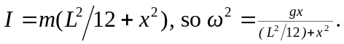 b) Differentiating the ratio 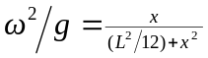 with respect to x and setting the result equal to zero gives

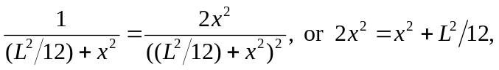

Which is solved for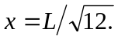
c) When is the value that maximizes the ratio 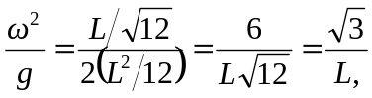
so the length is